Dharshini M

Date:2/1/2024

Mail: dharshini.m003@gmail.com

Topic: Creating Delta table

After creating the databricks workspace a cluster needs to be created and we need to upload a file in DBFS file upload.

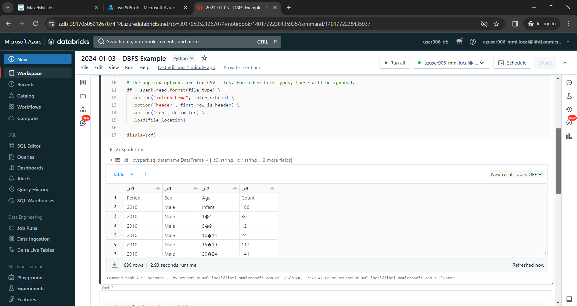

We can use any CSV file with a few fields

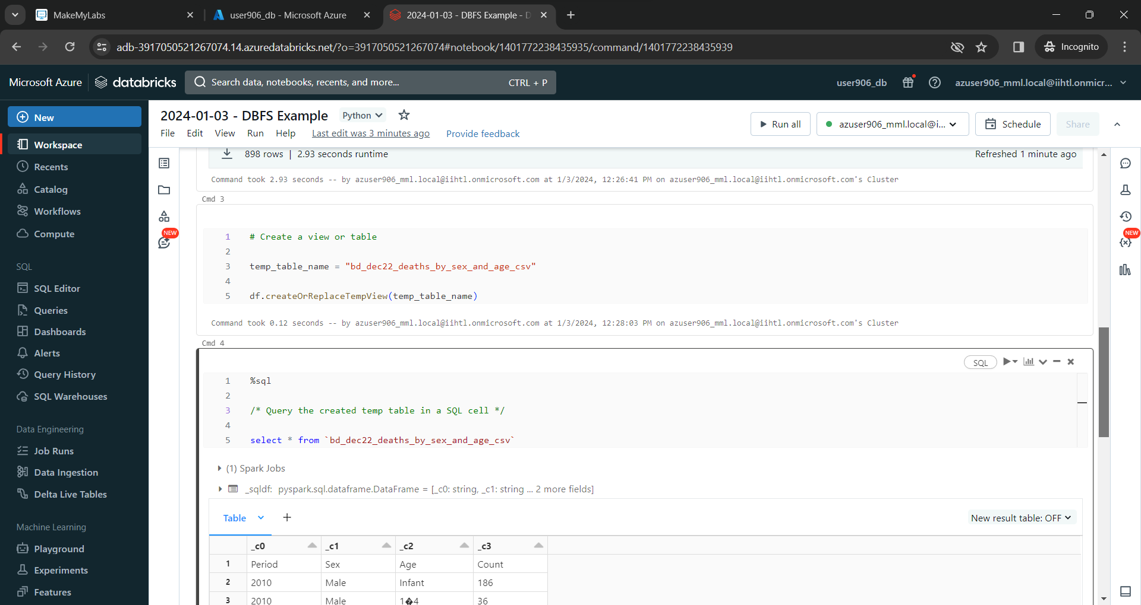

 we can execute the sample SQL query to ensure that the table can be queried,

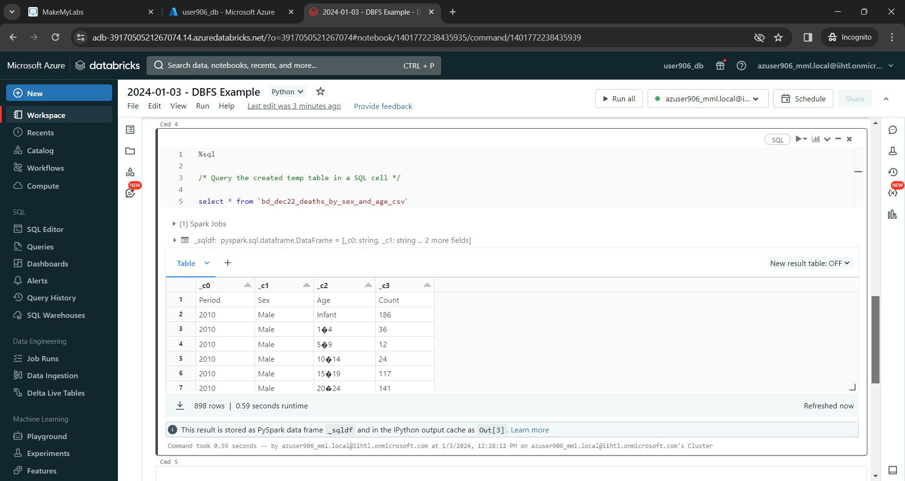

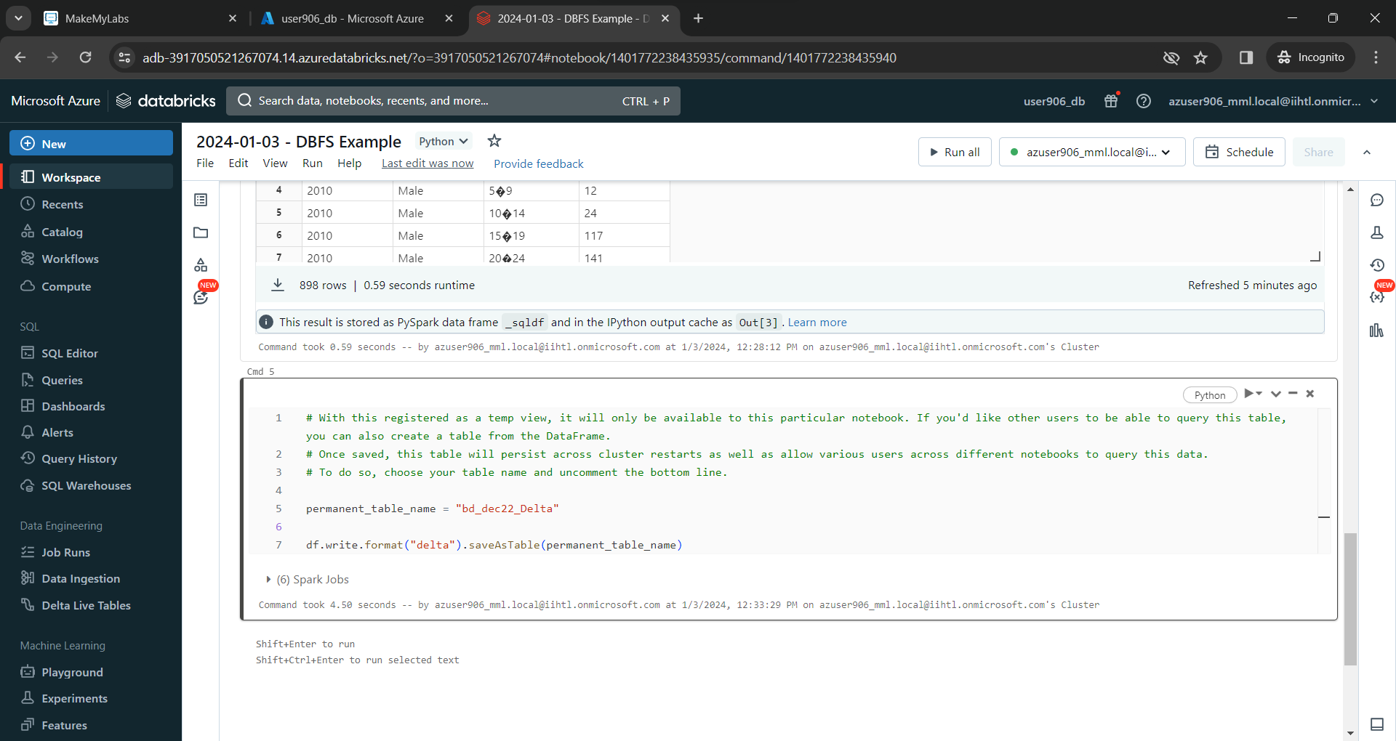

This line of code uses the data view held in the data frame and saves it as a table in delta format.

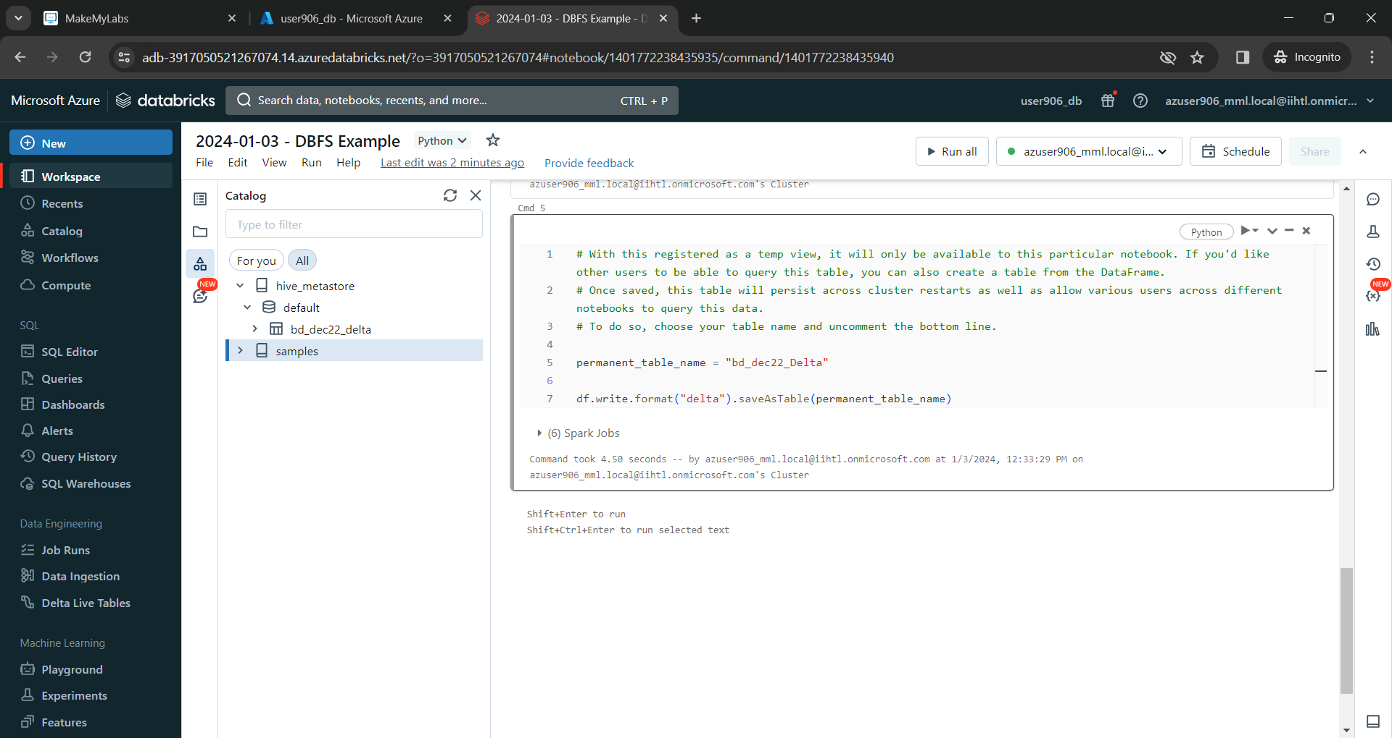

Delta table is created and it can be viewed